**Brooklyn torah gazette**

**For parshas mishpatim 5783**

Volume 7, Issue 23 (Whole Number 330) 27 Shevat 5783/ February 18, 2023

**Printed L’illuy nishmas Nechama bas R’ Noach, a”h**

For a free subscription, please forward your request to [***keren18@juno.com***](mailto:keren18@juno.com)

**Henya Federman, 40, Devoted Her Life to Locals and Visitors on the Virgin Islands**

**By**[**Menachem Posner**](https://www.chabad.org/search/keyword_cdo/kid/12145/jewish/Posner-Menachem.htm)

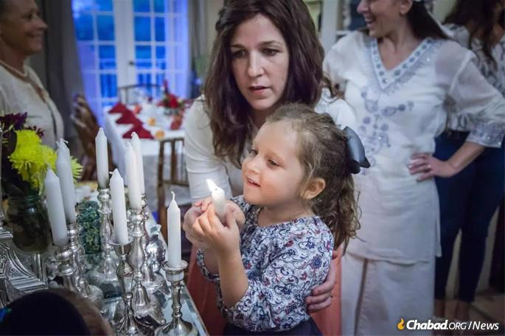

**Henya Federman assists a daughter in lighting Shabbat candles.**

With a ready smile and kind word, Henya Federman has greeted thousands of locals and visitors to the U.S. Virgin Islands.

As Chabad women leaders from all over the globe gather in Brooklyn, N.Y., to celebrate and gain inspiration at the International Conference of Chabad-Lubavitch Women Emissaries (Kinus Hashluchos), they will leave their workshops and sessions to join the funeral procession of Henya Federman, beloved and pioneering emissary to the Virgin Islands.

Henya passed away at the age of 40 on Wednesday, Feb. 8 (17 Shevat), after battling for her life for more than two months in the aftermath of a water accident that claimed the life of her 4-month-old daughter, Shterna.

Pulled out of the water and resuscitated after attempting to save her baby, Federman was flown to the mainland of the United States for emergency care. During the time that she lay hovering between life and death, countless people around the world increased in prayers, good deeds and Torah study in her merit.

**Lifelong Devotion to Others**

Henya was born in Milwaukee in 1982, the eighth child of Rabbi Yisroel and B. Devorah Shmotkin, who had been sent to the city by [the Rebbe—Rabbi Menachem M. Schneerson](http://www.therebbe.org/), of righteous memory—in 1968 to direct Lubavitch of Wisconsin.

Growing up with parents, grandparents and elder siblings all devoted to carrying out the Rebbe’s mission of sharing Jewish awareness, observance and celebration everywhere, it was her lifelong desire to follow suit.

Even as a teen, when she helped with her parents’ and siblings’ Hebrew school and camp, her care for others was legendary.

As news of the accident first spread, Virgin Islands’ locals and tourists formed social-media groups to share inspiration and anecdotes they had gleaned from Henya over the years, posting questions like “What’s your favorite Henya insight?” and “What’s your best parenting tip from Henya?”

**Nurtured a Unique Bond with Each Individual She Encountered**

As each one viewed him or herself as Henya’s “best friend,” it soon became apparent that they all were, as she nurtured and cherished a unique bond with each individual she encountered.

As the “Henya memories” continued to flow, they concluded, as did others across the globe, that the best gift they could give her was to increase in mitzvah observance and acts of kindness, and to encourage others to do the same.

Tina Shayani frequently spends time on the island with her family. She [told Chabad.org](http://www.chabad.org/news) that Henya was her close friend and “rebbetzin on speed dial” because she was somehow always available to answer any questions.

“Rabbi Asher and Henya are always so warm and helpful, and Henya is like a sister to me,” she said. She reported that her children looked forward to their trips to St. Thomas so they could visit the Federmans, who taught the Shayanis a truly meaningful and deep-felt kind of Judaism—something they never experienced before.

Shayani honored Henya by taking a fellow Jewish woman to the *mikvah*, or ritual bath, for the very first time—helping her fulfill a [mitzvah](https://www.chabad.org/library/article_cdo/aid/1438516/jewish/Mitzvah.htm) she knew Henya cherished.

Concurrently, Henya’s seemingly countless friends—people from around the world who were impacted by her—began encouraging *their* own families and friends to take on [a mitzvah related to family purity](https://www.chabad.org/theJewishWoman/article_cdo/aid/323424/jewish/Mikvah.htm). The effort has received hundreds of commitments to date. One participant pledged to donate towards the building of a new [*mikvah*](https://www.chabad.org/theJewishWoman/article_cdo/aid/323424/jewish/Mikvah.htm) while another committed to studying the laws of family purity. One woman in California reported that she’s been reaching out to women in her community and, in an effort to encourage them to engage with this foundational mitzvah, speaking with them about the sacredness and beauty of *mikvah*.

It wasn’t limited to *mikvah;*similar initiatives came together organically around the mitzvahs of Shabbat candle-lighting and *tefillin*.

**Thousands Share Their Memories**

Over the past months, thousands of former campers, students and beneficiaries of her legendary care and hospitality have reached out to share their memories. “Henya was my camp counselor when I was a kid,” wrote Stephanie Rosenberg on Facebook. “We talked from time to time, the last being right after my father passed. She sent me a book about grieving, which I still keep at my bedside.”

“She was my favorite counselor at Camp Gan Israel of Milwaukee, year after year,” wrote another. “She brought so much joy and enthusiasm. My memories with her bring me so much happiness to this day.”

**‘Better than Disney World!’**

On Facebook, Liza Wiemer recalled her sons’ first day at the Milwaukee Community Hebrew School. She was nervous because they hadn’t enjoyed their previous Hebrew school. To her amazement, when she picked them up, the boys declared that Hebrew school was ‘better than Disney World!’ ”

Henya was their teacher, and she showered her charges with warmth and love as she taught them about Judaism week after week. So caring was she that the children looked forward to school every Sunday.

Following her marriage to California native, [Rabbi Asher Federman](https://www.chabad.org/multimedia/video_cdo/aid/3848200/jewish/The-Jewish-Spirit-Amidst-the-Devastation-in-the-Virgin-Islands.htm), the couple began looking for the corner of the world where they could establish a [Chabad](https://www.chabad.org/library/article_cdo/aid/244369/jewish/About-Chabad-Lubavitch.htm) presence of their own. That place turned out to be St. Thomas, possibly the smallest locale of a Chabad outpost until that time.

During the Federmans’ first Chanukah on the island, they stationed yeshivah students near the docks, where they greeted six cruise ships a day, each unloading about 3,000 passengers. Before long, shouts of “Happy [Chanukah](https://www.chabad.org/holidays/chanukah/default_cdo/jewish/Chanukah-Hanukkah.htm)” were ringing out, up and down Main Street. Menorahs were being passed from person to person.

One man e-mailed the Federmans later through Chabad.org to tell them that upon returning to his cruise ship, his group was inspired to hold a Chanukah party. Five-hundred-and-sixty people showed up—and almost 250 of them brought the tin menorahs they received from the Federmans and lit them at the party. Some of the others relit the menorahs in a second shift.



**Rabbi Asher and Henya Federman and children on St. Thomas.**

Success followed success, and each challenge made the Federmans stronger and more resilient, more determined and more devoted.

“Living on an island that is nine miles by three miles can get to you,” Henya shared with her fellow *shluchot* at the 2014 International Conference of [Chabad-Lubavitch](https://www.chabad.org/library/article_cdo/aid/244369/jewish/About-Chabad-Lubavitch.htm) Women Emissaries “We islanders call it rock fever. It might be hard for someone living on the mainland to understand, but when you live on an island, the sight of a departing plane, even though it may be full of total strangers, can make you choke up. A cruise ship slowly drifting away can leave you with a heaviness inside.”

Counseling her colleagues with the ideals she herself lived by, she concluded: “If you’re ever feeling alone or wondering what you’ve achieved, just remember that you are part of both a huge army and a close-knit family. Your role is unique and plays an integral part in bringing each Jew closer to Hashem.”

**Offered Shabbat Services and Dinners**

Bringing people closer to G‑d, one at a time, the couple built up a well-attended synagogue, a lively Hebrew school, kosher-food services and, of course, joyous Shabbat services and dinners for both locals and tourists.

“Her kind and sweet nature inspired and brought so many to her beautifully set Shabbat table—with incredible food!—and serves as a constant reminder for so, so many, of the sweetness and approachability of Yiddishkeit and mitzvot,” said David Brainson, a St. Thomas resident and dear friend of the Federman family.

“With her gracious hosting and incredible eye for style, she showed the beauty of [mitzvot](https://www.chabad.org/library/article_cdo/aid/1438516/jewish/Mitzvah.htm), so anyone could see that mitzvot are worth doing, and worth doing right.”

Even more than from the activities and programs she organized and planned, islanders say they learned just from watching how she educated her children, giving each one individualized attention and lovingly guiding and nurturing them through childhood.

Baldwin says that looking around the room at a pre-Purim event, she realized that “everyone there felt special. Henya had a way of doing that. She made everyone around her feel good and feel at home.”

**The Essence of Authenticity**

“Down to maybe the number of fingers on one hand, Henya was one of the greatest people I’ve ever known,” said George S. Eltman, formerly a judge in St. Thomas and now of Jerusalem. “Henya was the essence of authenticity. And commitment. And generosity. And kindness, such kindness. Because she seemed to know just who she was, in a most profound way, her authenticity shone bright.”

As the Federmans’ work burgeoned and blossomed, so did their family, and they were blessed with their 13th child, Shterna, last summer.

“Henya was such a sweet woman and an amazing mother,” said Aisha Zakiya, who periodically photographed the family over the past 10 years. “I am not Jewish, but I so appreciate what she imparted to me about [G‑d](https://www.chabad.org/library/article_cdo/aid/433240/jewish/God.htm), religion, commitment, and family. She touched me in so many ways and will continue to touch me.”

In a message they addressed earlier this evening to “our dear extended Virgin Island family,” Henya’s siblings wrote: “We know that during these trying couple of months you ached right along with us, and right along with us you prayed and beseeched G‑d with all your might, and each of you in your own special way did all kinds of special things to share Henya’s beautiful life and ways with others.

“Henya will live on through each of you, her dearest friends and family, sharing her warm light and love with all the concentric spheres of your own lives and influence.”

*Excerpted from the February 8, 2023 dispatch of Chabad.Org*

**Rav Avigdor Miller on**

**Helping Out in Medinas Yisroel**

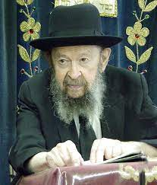

**QUESTION:** **How could you say that Jews should avoid doing military service in Israel if there are millions of Jews who need to be protected?**

**ANSWER**: Oh, this is a harking back to an old discussion. So, in case you’re a Zionist, keep your blood pressure down because I’m not going to spare you anything. However, you don’t have to accept what I’m telling you – but I’m not going to accept what you’re saying.

So, I’ll ask this gentleman here, the questioner, what’s he doing here? Why is he a slacker?! There are millions of Jews who have to be protected – let him go and sign up. The answer is, you have your reasons. You think, maybe, that right now you want to study here and become a physician and eventually you’ll go there and you’ll help them out in that way. So, you have an idea to help the people there in a different way; not by putting on a uniform right now. That’s your idea of helping them; it sounds reasonable.

So, we also have ideas of how to help the people in Eretz Yisroel. And one idea is to send a lot of money to the yeshivos, to poor talmidei chachomim. That money goes into the economy. Any money you send is going to be spent there; it’s spent in the butcher shops and in the grocery shops. It’s spent on products and you’re therefore supporting the people who work in the factories. Whatever money you send to talmidei chachomim living there goes straight into the economy. It’s very important.

**Money is the Blood of a Nation**

Believe me, if you asked the people at the head of the state, “Would you excuse about twenty or fifty or a hundred or a thousand people from the army to go to the United States and raise big sums for your economy?” so they’d gladly agree, because money is the blood of a nation. You can’t make war without money.

So, if you really want to help out, I’ll give you a list. I have a list of blue-ribbon poor families who are doing a big job for Eretz Yisroel. They’re raising a lot of children. You know, there are other Jews who are not raising children. Eretz Yisroel is a country of a great deal of abortions.

Authorities have said that at least a million Jewish children were aborted from the beginning of the state until a few years ago. That was years back; now it’s much more. All the while, the Arabs are having children like nobody’s business. They never had so many children before. Because the Arabs in Eretz Yisroel are getting the best medical treatment. The Arabs in Israel are increasing more than the Arabs in any other place in the world.

**“It’s Only a Matter of Time”**

So how long will it take before the Jews will be outnumbered? It’s only a matter of time. Even right now there’s a big problem – the Jews are dwindling and the Arabs are snowballing. So here you have some Jews who are busy trying to equalize the population; they are the hope of the future  – the apikorsim in Tel-Aviv are not doing their part – so you should send money to them and that money goes into the lifeblood of the nation.  That’s one way of helping to defend the Am Yisroel. It’s a beautiful way of supporting the people there.

And if you want another way to help the Jews there, pay attention. You have to know השם איש מלחמה – Hashem is the one making the wars against the State of Israel. Now, of course they wouldn’t believe that, but we do! Hakodosh Boruch Hu is the Man of War. בעל מלחמות – He makes the wars. And there are reasons why He makes wars. Do you know why He makes wars on Israel?

Listen to me; but keep your blood pressure down. A man told me today that he was in Israel in 1966. He went to a movie. This is a kind of a man who’s not a shomer mitzvos. He went to a movie and he saw – now, I’ll have to wash my mouth out after I get through telling this to you – he saw movies where a certain form of toeiva was being practiced in the movie, on the screen.

Now, what that means, it’s enough, I can’t tell you anymore. And it was supposed to be only for adults. It means past sixteen. Sixteen and up, that’s adults over there. But he was in places, he was in various theaters there, and this is what he told me. He told me that he saw children of five and six years old at these movies. Which means that the youth in Eretz Yisroel are being conditioned for a life of degeneracy.

**Unfortunately, A Gay Haven in Israel**

The gays are planning next year an international world conference of gays in Yerushalayim. And he said that they have two synagogues of gays in Eretz Yisroel. He said three but I want to make it within the bounds of surety. And in Tel Aviv you have anything that you can find in Times Square – they’re not behind a bit.

Now, we want to save העם היושב בציון – we want to help out the Jews who live in Eretz Yisroel. We want to stop the wars; and therefore, if we’re going to fight against the adverse influences there, if we’re going to exert pressure on the government that they should remedy these evils, maybe we can have a hand in protecting the Jews in Eretz Yisroel.  We want them to wipe out pornography.

We want them to stop drafting girls in the army. Because girls in the army means only one thing. Like that Israeli general who wrote a book about the Israeli army. We can trust what he tells us. And he states openly that for most girls the induction into the army is their first experience in znus (immorality). For most Israeli girls the army is a house of harlotry.

**The Problems with the Israeli Army**

So now you have an institution, the Israeli army, which is one big house of prostitution and the girls are forced into it. Now that’s not my statement. It’s a statement by a general who wrote a history of the Israel Defense Forces and he makes that statement openly. He doesn’t make it in a clandestine secret way that you have to read between the lines. He says it openly. They’re not ashamed.

So, we have to exert pressure because we don’t want that. Because השם אלקיך מתהלך בקרב מחניך להצילך מאויביך. It says Hashem walks in your midst to help you against your enemy. But it says ולא יראה בך ערוות דבר ושב מאחריך – If He’ll see immorality among you, so the Shechinah will depart. It means He’ll let you be defeated. So, if we want to help the people in Eretz Yisroel be protected from the enemies, it’s our job to speak up and fight against all of the wickedness in the State of Israel.

So, just as this young man who doesn’t go right now and put on a uniform because he wants to help them eventually by becoming a physician, so we’re also helping in our own way. It’s a very big help if you write letters and protest against what’s going on there. Of course, now there’s a better regime. Up till now there was a Marxist regime but now there’s a better regime and let’s hope that these things are going to change.

*Reprinted from the February 8, 2022 email of Toras Avigdor. Adapted from Tape #204 – February 1978*

**The Importance of a Jew and G-d Loaning Money to the Poor**

**From the Teachings of the Lubavitcher Rebbe**

**Rabbi Menachem Mendel Schneerson, Zt”l**

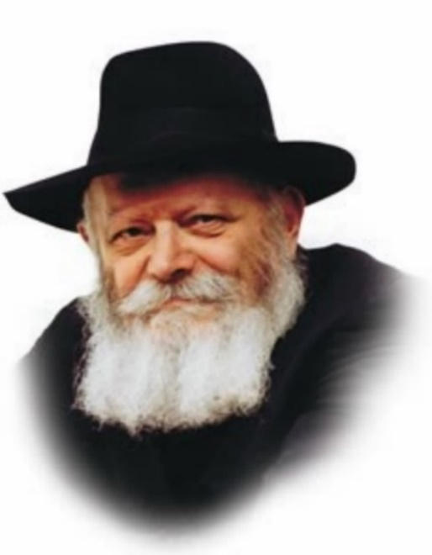

One of the commandments contained in this week's Torah portion, Mishpatim, is "If you will lend money to any of My people." Lending money to a poor person is considered a mitzva.

According to our Sages, G-d performs all of the same mitzvot He commands the Jewish people to observe. "He declares His word to Jacob, His statutes and His judgments to Israel." The Torah's "statutes" and "judgments" are G-d's statutes and judgments! Thus, G-d too observes the mitzva of "lending money to the poor," as it were.

Let us examine exactly what is involved in the transaction of a loan:

A loan consists of one person giving money to another, even though he is not obligated to do so. The money is a gift; the borrower does not give anything in exchange. Nonetheless, the person on the receiving end of the transaction is obliged to eventually repay the giver.

**G-d’s Loan to Us**

The Holy One, Blessed Be He, observes all of the Torah's commandments. G-d's "loan" to us, however, consists of the strengths and abilities He endows us with to succeed in our daily lives.

These gifts are not measured, nor does G-d grant them only to the deserving, just as monetary loans are not made solely to those in dire need. And yet, they are still "loans" and must therefore be repaid. But how do we repay our debt? By utilizing our strengths and abilities to carry out our Divinely-appointed mission in life, observing G-d's "statutes" and "judgments" in fulfillment of His will.

**Forbidden to Pressure the Borrower**

The second half of the above commandment reads "You shall not be a creditor to him, nor shall you lay upon him interest." It is forbidden for a lender to pressure the borrower into repaying his loan. He may neither ask for his money nor cause him distress. If the loan has not yet been repaid it is obvious that the borrower does not have the money to do so. In fact, the lender may not even show himself to the borrower, that he not be made to feel any embarrassment or shame.

G-d also observes the prohibition against being a creditor. G-d could easily demand payment by punishing His children and inflicting pain and suffering, but He does not. For it is forbidden for a creditor to cause sorrow to those who are in his debt. Instead, G-d acts toward the Jewish people with kindness and mercy, granting them all manner of revealed and open goodness.

*Reprinted from the Parshat Yisro 5758/1998 edition of L’Chaim (Issue #506) Adapted from Likutei Sichot, Volume 1*

**Rabbi Berel Wein on**

**Parshas Mishpatim 5783**

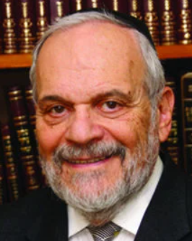

The Torah prescribes that a Jewish servant who wishes to remain permanently in servitude – he loves his master’s home and his family – is given a permanent mark, a hole in his ear, as an everlasting reminder of his choice. Rashi explains, based on the Talmud, that the ear that heard on Sinai that the Jewish people are G-d’s servants and not to be servants to other humans is to be drilled with an awl as a stark reminder of his poor choice in life.

The Talmud taught us that a truly free person is someone whose guide in life is Torah. The choice of servitude over freedom is anti-Jewish and anti-Torah in its very makeup. In the ancient world and even in later times, slaves were branded so that all could see that they were the chattel of their owner.

The Torah’s instruction to bore a hole in the ear of the Jewish servant was to remind everyone of just the opposite idea. That this slave belonged to no other human but rather was to be a servant of G-d – that was the message of the drilled ear. Freedom and independence mean that we bow to no one but to our Creator alone.

 Having other masters in life is a rejection of the Jewish mission and Judaism’s true understanding of life’s purpose. Jews have often in our long history been made to serve in involuntary servitude and slavery. But voluntarily giving up one’s freedom of action and behavior is abhorrent to Jewish ideals and tradition.

The ancient world, as well as much of the later worlds, was built upon the institution of slavery, forced labor and involuntary servitude. In our time governments that preached equality and nobility enslaved others simply because they suspected them of having different ideas.

The mocking slogan at the entrance to Auschwitz “Work makes one free” symbolized the ultimate form of slavery and murder. The Gulag was the place where millions succumbed doing useless work. The great White Sea Canal of Stalin was literally a canal that led to nowhere while myriads of people died in the process of building it, often only with their bare hands.

The Jewish people were coming forth from Egypt after centuries of slavery. One would have thought that having themselves experienced that type of servitude they would not wish to inflict it upon others. However, Midrash teaches us that even in Egypt there were Jews who somehow owned other Jews as slaves. It would take millennia for Jews to be completely weaned from the practice of slavery.

Such is the dark side of human nature and behavior. But the process of drilling the ear of one who wishes to remain a permanent slave reminds the Jewish society of the inherent wrong in the deprivation of people’s freedom. Only G-d has the right to ask us to be His servants. And those who truly serve G-d have no interest in depriving others of their freedom. The message of freedom that was heard on Sinai should reverberate in all of our ears constantly.

*Reprinted from this week’s website of rabbiwein.com*

**The Historic Meeting of Ben-Gurion and the Chazon Ish**

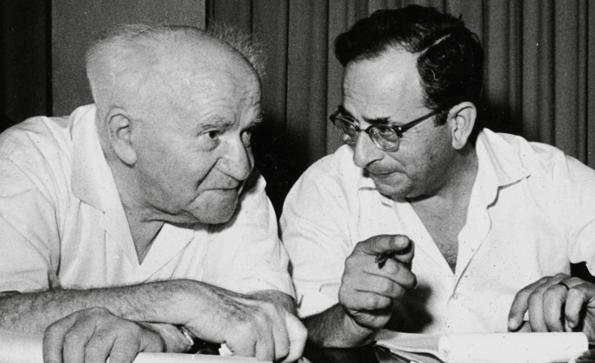

**Israeli Prime Minister David Ben-Gurion and his personal secretary Yitzchak Navon**

On Rosh Chodesh Cheshvan in 1952, the talk of the day in Israel centered on the fascinating meeting of the Chazon Ish and Israel’s first prime minister, David Ben-Gurion. The statements during the meeting has been quoted countless times and has been the source of numerous ideological discussions.

What prompted the famous meeting? Ben-Gurion was making great efforts to gather a majority for a bill for national service for girls who were exempted from service in the IDF due to religious reasons.

The Chareidi Rabbanim and the Rabbanut expressed strong opposition to the bill and Ben-Gurion realized that if he wanted the support of the Chareidi parties, he would have to gain the support of their leaders. Since the representatives of the Chareidi party, Poalei Agudas Yisrael (PAGI), often said that they had to consult with the “Chazon Ish,” Ben-Gurion decided that he had to meet this influential leader of Chareidi Jewry.

Ben-Gurion sent his military commander Nechemia Argov to find out if such a meeting could take place. The Chazon Ish responded: “The door is always open.” The meeting was arranged through PAGI representative Binyamin Mintz. Ben-Gurion, accompanied by his personal secretary [and future Israeli president] Yitzchak Navon, visited the Chazon Ish that evening in his humble Bnei Brak apartment. [Close associates had offered to buy the Gadol new furniture in honor of the meeting but he firmly refused.]

Navon, who was the only witness to the meeting apart from the Chazon Ish and Ben-Gurion, later wrote: “I too went into the room and sat down in the corner and recorded the conversation. I saw a short Jew, with a handsome face, bent over, a table, a chair, a rickety bed and books, books, books.

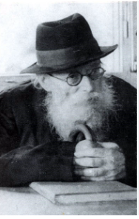

**The Chazon Ish, zt”l**

“Everyone thought he would talk to him about the recruitment of girls but there was not one word about that. They sat opposite each other, across a small table.”

Ben-Gurion wrote in his diary later: “I asked him the question to which I have yet to receive a sufficient answer from my observant friends. How will we, religious and non-religious Jews, live (together) without exploding from within? We have different views. How do we live together?”

The Chazon Ish responded: “If two camels meet on a path, and one camel is bearing a load and the other is not bearing a load, the one without a load must give way to the camel bearing a load. We religious Jews are likened to the camel bearing a load – we have a burden of many mitzvos.” The Chazon Ish provided the nimshal as well, saying: “We, the frum Jews, are carrying the burden of Torah and mitzvos, and the non-religious Zionists, ‘whose wagon is empty’ must step aside for us.”

**Yitzchak Navon’s Recollections**

According to Yitzchak Navon [as quoted by Yediot Achranot], Ben-Gurion then replied: “And on this camel is there no burden of a mitzvah? And the mitzvah of settling the land is not a mitzvah? And is it not a burden?

And the mitzvah of protecting life is not a mitzvah? And what are the young men doing that you are so opposed to, and they are sitting on the borders and guarding you, isn’t that a mitzvah?”

Chazon Ish: “They are sustained because we learn Torah.”

Ben-Gurion: “If those young men weren’t protecting you, the enemies would have destroyed you.”

Chazon Ish: “On the contrary, because of our Torah learning, they

can live and work and guard.”

The argument between the two continued for a long time, and as Navon described it: “They each maintained their positions and repeated them several times, again and again, without coming closer to each other.”

**A Beautiful Smart Jew**

After they left, Ben-Gurion said: “This is a beautiful, smart Jew with beautiful, smart eyes, [and he is] modest. It’s interesting where his power and influence come from. And how will we live in this country? The ‘ingathering of the exiles’ is not a simple thing. There are many things that can break up our society, but that is the most important question. This is a more serious danger than any external enemy.”

Despite the fact that he apparently did not receive a satisfactory answer to his question, Ben-Gurion was awed by the Chazon Ish. Shortly afterward, he sent him a photo of the two of them, to which he added the caption: “May your honor allow me to add that my visit to him was an unforgettable experience for me.”

Following the meeting, the Prime Minister’s Office issued a statement: “Ben-Gurion met privately with Rabbi Avrohom. Yeshaya. Karelitz (“The Chazon Ish”) in Bnei Brak yesterday. The purpose of the visit was to exchange general views regarding the following issue: How can observant and non-observant (Jews) live together harmoniously in the State of Israel? The question of recruiting women (to the army) was not discussed and the visit had no relation to current political matters.”

*Reprinted from the Parshat Mishpatim 5783 email of Reb Yedidye Hirtenfeld’s whY I Matter parsha sheet for the Young Israel of Midwood in Brooklyn. Originally published on the October 26, 2022 website of The Yeshiva World.*